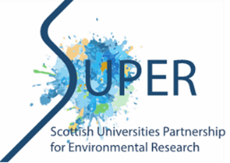

SUPER-NERC RESEARCH EXPERIENCE PLACEMENTS (REPs), SUMMER 2024

SUPERVISOR APPLICATION PROFORMA

Full name | Click or tap here to enter text.
Contact email address | Click or tap here to enter text.
Institution | Click or tap here to enter text.
School/Department | Click or tap here to enter text.
Proposed project title | Click or tap here to enter text.
Please provide a brief overview of the research / learning and teaching project proposed.
(Max 500 words)

Click or tap here to enter text.
Please detail how you propose to integrate the appointed student into the research / learning and teaching culture within the school/department. (Max 500 words)

Click or tap here to enter text.
Please provide detail on potential training and developmental opportunities the appointed student will be able to participate in during the placement and how this will develop their skills. (Max 500 words)

Click or tap here to enter text.
Do you have a SUPER PhD who could act as a mentor?
Please state name of PGR, or let us know if you need help with this.
Click or tap here to enter text.

Please email your completed form to: superdtp@st-andrews.ac.uk by the deadline of 12 noon Thursday, 28 March 2024

